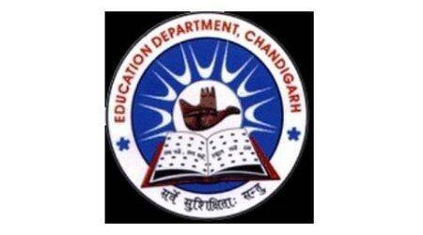
School Code : 24208 | Affiliation No. 2620025
GOVERNMENT MODEL SENIOR SECONDARY SCHOOL
SECTOR 38 WEST DMC CHANDIGARH. PHONE : 0172-2617001
Website: www.gmsss38wdmc.in. E-Mail ID: gsss38west@yahoo.in

MEMO NO : DATE:5/5/2021
WATER ,HEALTH AND SANITATION CERTIFICATE
It is hereby certified that the fresh water in our school is supplied by the Municipal Corporation, Chandigarh. Water is pure and safe for drinking. Water tanks in the school are properly cleaned bi-annually.
PRINCIPAL
GMSSS 38 WEST DMC

